Michael Gorospe Inso- ACCP- Aptech Qatar

A server-side dynamic website is managed by an application server processing server-side script. The framework determines how the assembly of every web page proceeds, including the setting up of more client-side processing. -Wikipedia

*Driverless an Autonomous Vehicle*

Dynamic Websites



Statement and Confirmation of Own Work

|  |
| --- |
| ***A signed copy of this form must be submitted with every assignment.***  ***If the statement is missing your work may not be marked.*** |

Student Declaration

I confirm the following details:

|  |  |
| --- | --- |
| Candidate Name: | MICHAEL G. INSO |
| Candidate ID Number: | 00188933 |
| Qualification: | L5DC |
| Unit: | DYNAMIC WEBSITE |
| Centre: | APTECH QATAR |
| I have read and understood both NCC Education’s *Academic Misconduct Policy* and the *Referencing and Bibliographies* document. To the best of my knowledge my work has been accurately referenced and all sources cited correctly.  I confirm that this is my own work and that I have not colluded or plagiarised any part of it. | |
| Candidate Signature: |  |
| Date: | 4/14/2021 |

**OPS020_dec16_Candidate+Statement+of+Own+Work.doc**

**OPS020_dec16_Candidate+Statement+of+Own+Work.doc**

Table of Contents

Table of Contents1

Figures3

Acknowledgement4

Introduction5

Task 16

1. ***Introduction and HOME Page*** 6
2. ***Introduction and HOME Page (2)*** 6
3. ***Introduction and HOME Page (3)*** 7
4. ***ABOUT US Page*** 7
5. ***ABOUT US Page (2)***8
6. ***CARS Page*** 8
7. ***CARS Page*** 9
8. ***INSURANCE Page*** 9
9. ***INSURANCE PARTNERS***10

Task 210

1. ***Sign Up Page*** 10
2. ***Login Page (Wrong email or password)*** 11
3. ***My Account Page*** 11
4. ***My Bookings Page*** 12

Task 312

1. ***CONTACT Page*** 13
2. ***Contact Us Page*** 13
3. ***Map Page*** 13
4. ***FAQ Page*** 14

Task 4 14-16

Task 516

References17

Bibliography17

Figures:

***Figure 1: a.) Introduction and HOME Page***6

***Figure 2: b.) Introduction and HOME Page (2)*** 6

***Figure 3: c.) Introduction and HOME Page (3)*** 7

***Figure 4: d.) ABOUT US Page*** 7

***Figure 5: e.) ABOUT US Page (2)*** 8

***Figure 6: f.) CARS Page*** 8

***Figure 7: g.) CARS Page (2)*** 9

***Figure 8: h.) INSURANCE Page*** 9

***Figure 8: h.) INSURANCE PARTNERS*** 10

***T2 Figure 9: i.) Sign Up Page*** 10

***Figure 10: j.) Login Page (Wrong email or password)*** 11

***Figure 11: k.) My Account Page*** 11

***Figure 12: l.) My Bookings Page*** 12

***T3 Figure 13: m.) CONTACT Page*** 12

***Figure 14: n.) Contact Us Page*** 13

***Figure 15: o.) Map Page*** 13

***Figure 15: p.) FAQ Page*** 14

**Acknowledgment**

This project would not have been possible with a lot of research and full-stack development skill implementing my front-end, back-end, and database, etc. skills with programming languages like Java (Spring), PHP, Ruby, JavaScript, HTML 5, CSS 3, and Objective C, etc.

I would like to express my special thanks of gratitude to Aptech Qatar Education Centre who gave the amazing opportunity to do this strenuous project on the topic Dynamic Website for NCC-UK Diploma 5 Computing, which also helped me in doing a lot of exploration and investigation and I acquired so many new knowledge and skills about Dynamic Website Design & Development.

Secondly, I would like to thank professor, staff and the faculties for their great assistance and would also like to thank my **family** who still give me sponsorship and accommodation they helped me a lot in completing this project within the limited duration of time. The year 2020 was a great distress to all of us because of the covid-19 pandemic. I hope 2021 would be a great year to all of us and all would go back to normal.

**Introduction**

This project will use the fictional world example of Driverless A.I. Cars Inc. is a company manage and administered by an Artificial Intelligence highly ultramodern and ahead of time concept of a company. Fictitious in the last 100 years but was made into materiality by modern companies like Tesla, Waymo by Google, and Comma.Ai, etc.

Autonomous Vehicles are gaining in popularity. I have been asked to create a website that provides information about autonomous vehicles, including about the Artificial Intelligence (AI) technology that is used to develop these vehicles. A company called “Driverless” are looking for you to create a dynamic website which should include content that changes as the requirements of the user change, e.g., real-time banners. The website should offer a fluid layout and should be responsive to reading and navigation on different devices. It should include animation and interaction when accessing product recommendation displays.

# ***Task 1***

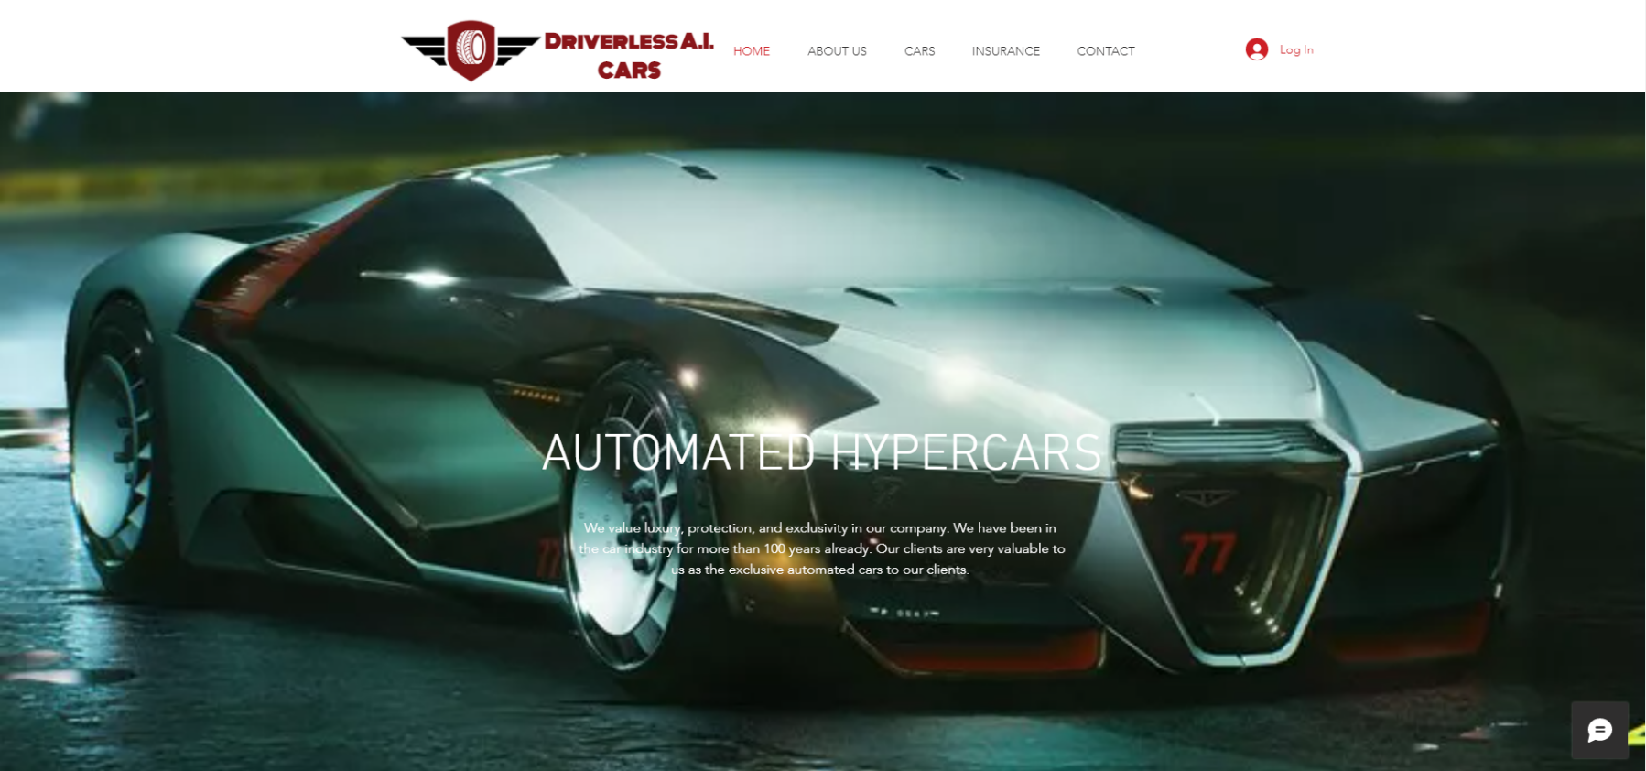

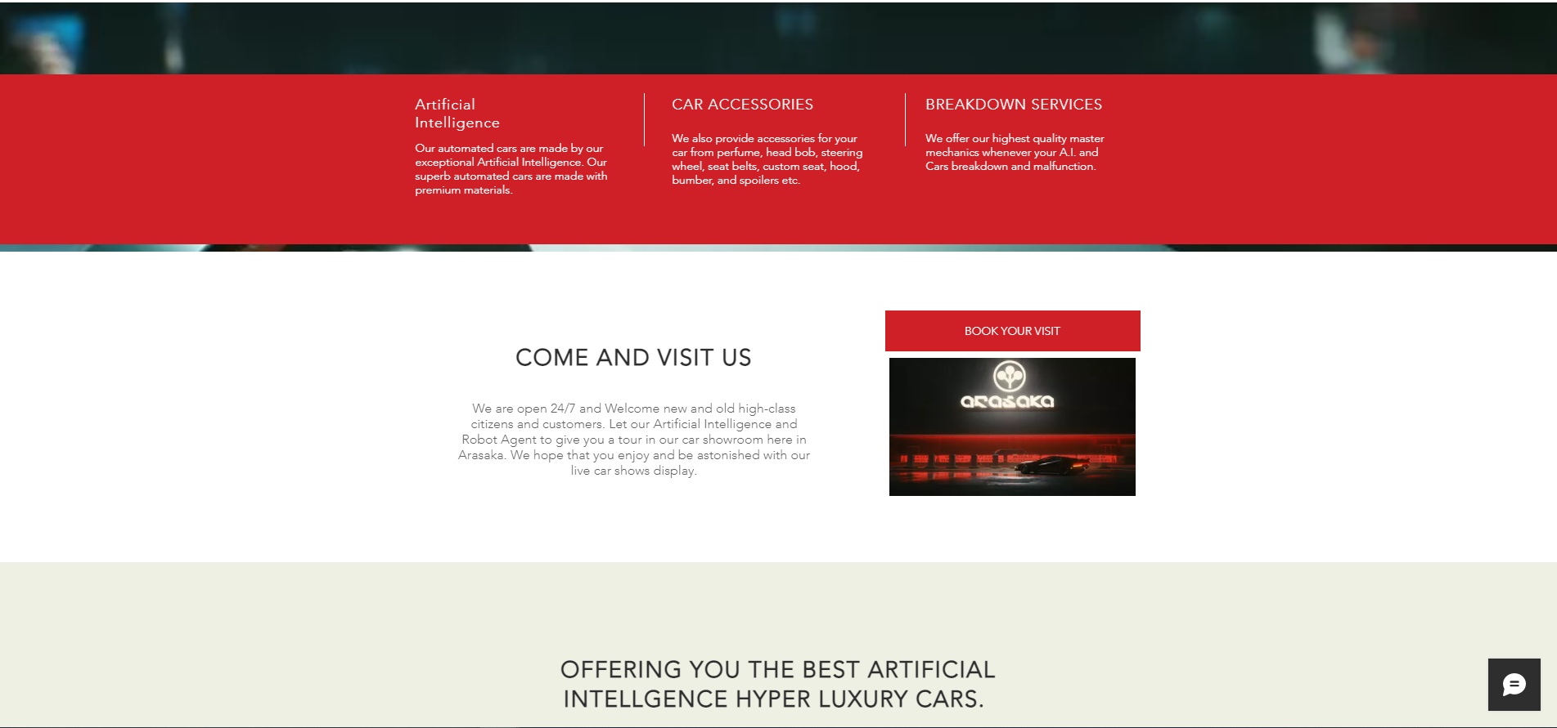***Figure 1: a.) Introduction and HOME Page***

***Figure 2: b.) Introduction and HOME Page (2)***

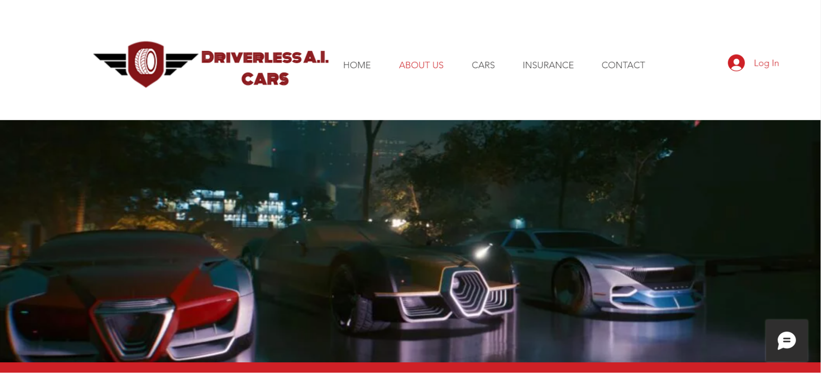***Figure 3: c.) Introduction and HOME Page (3)***

***Figure 4: d.) ABOUT US Page***

**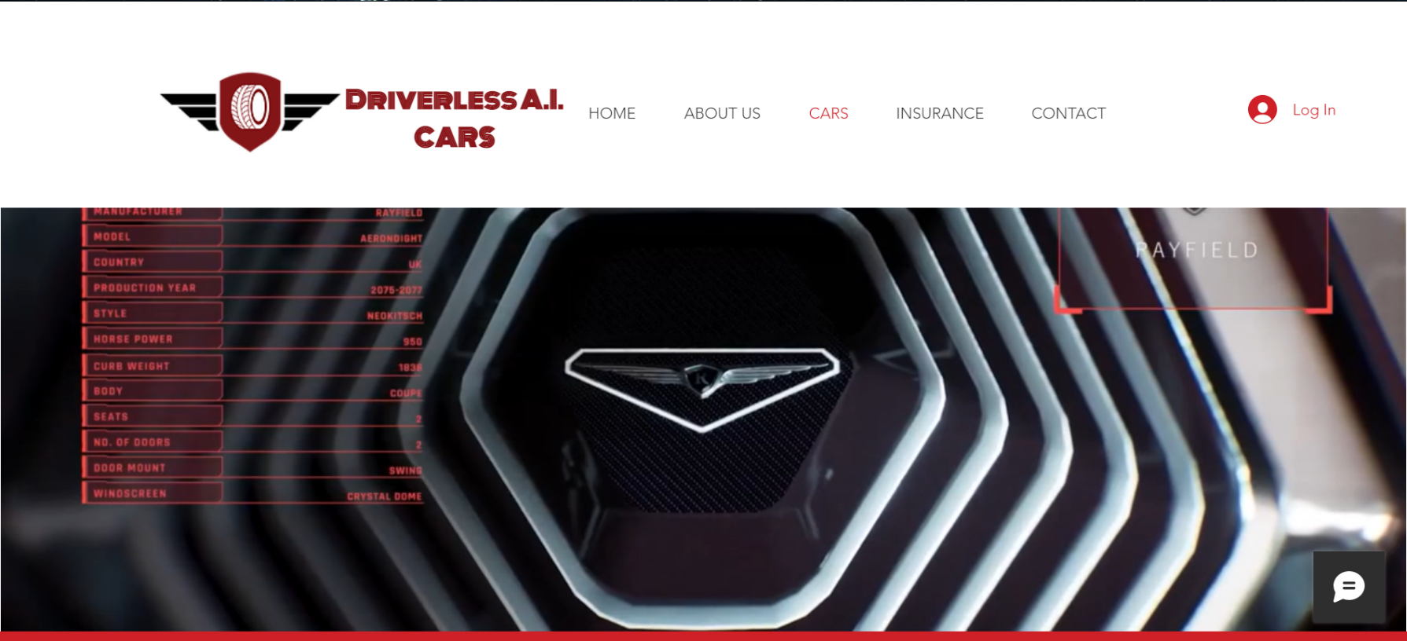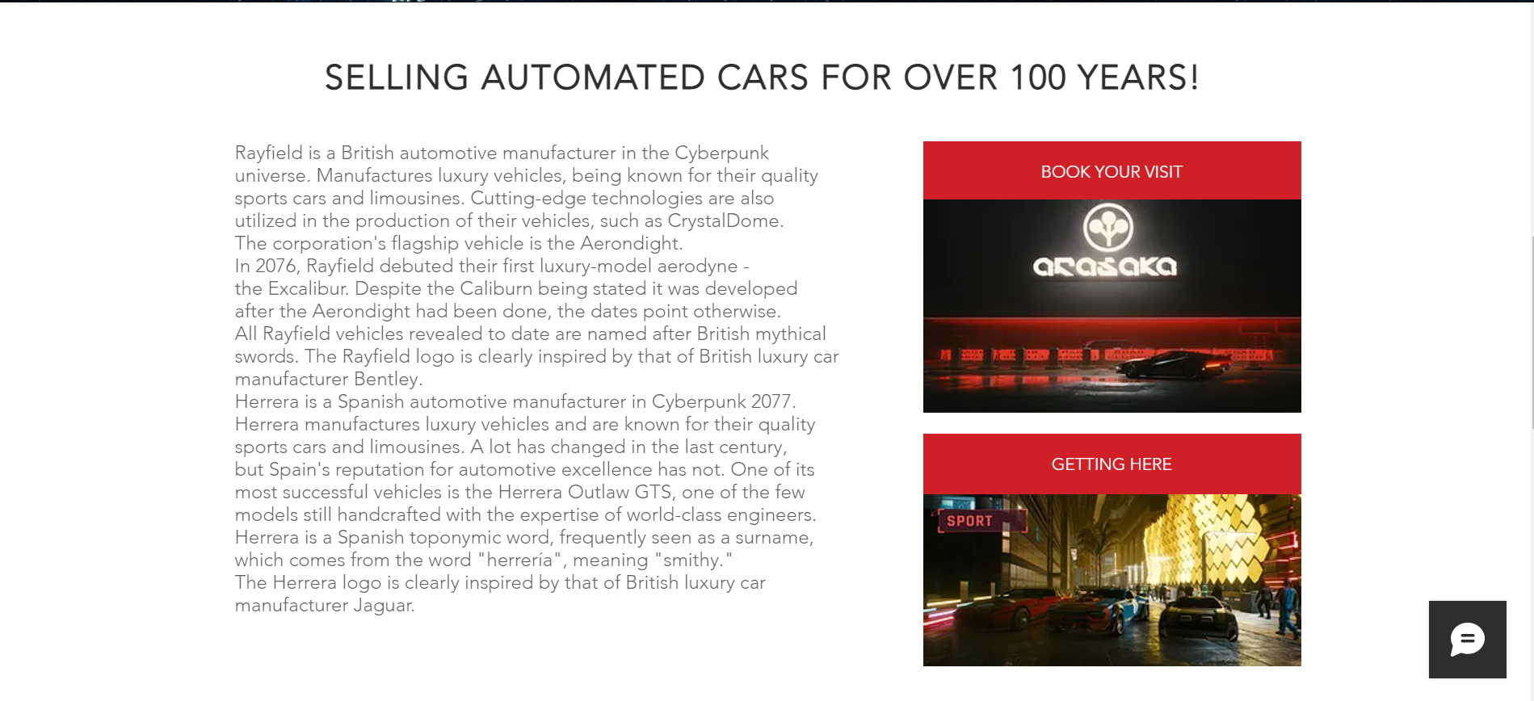*Figure 5: e.) ABOUT US Page (2)***

***Figure 6: f.) CARS Page***

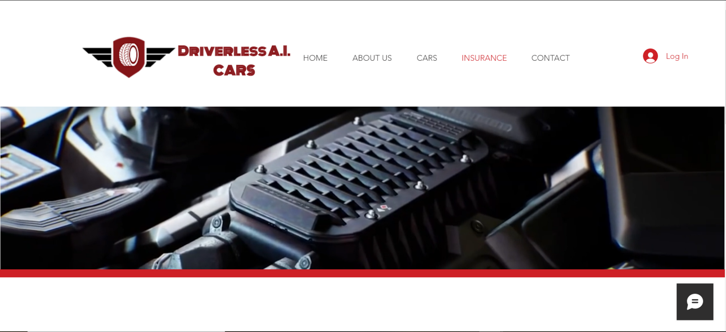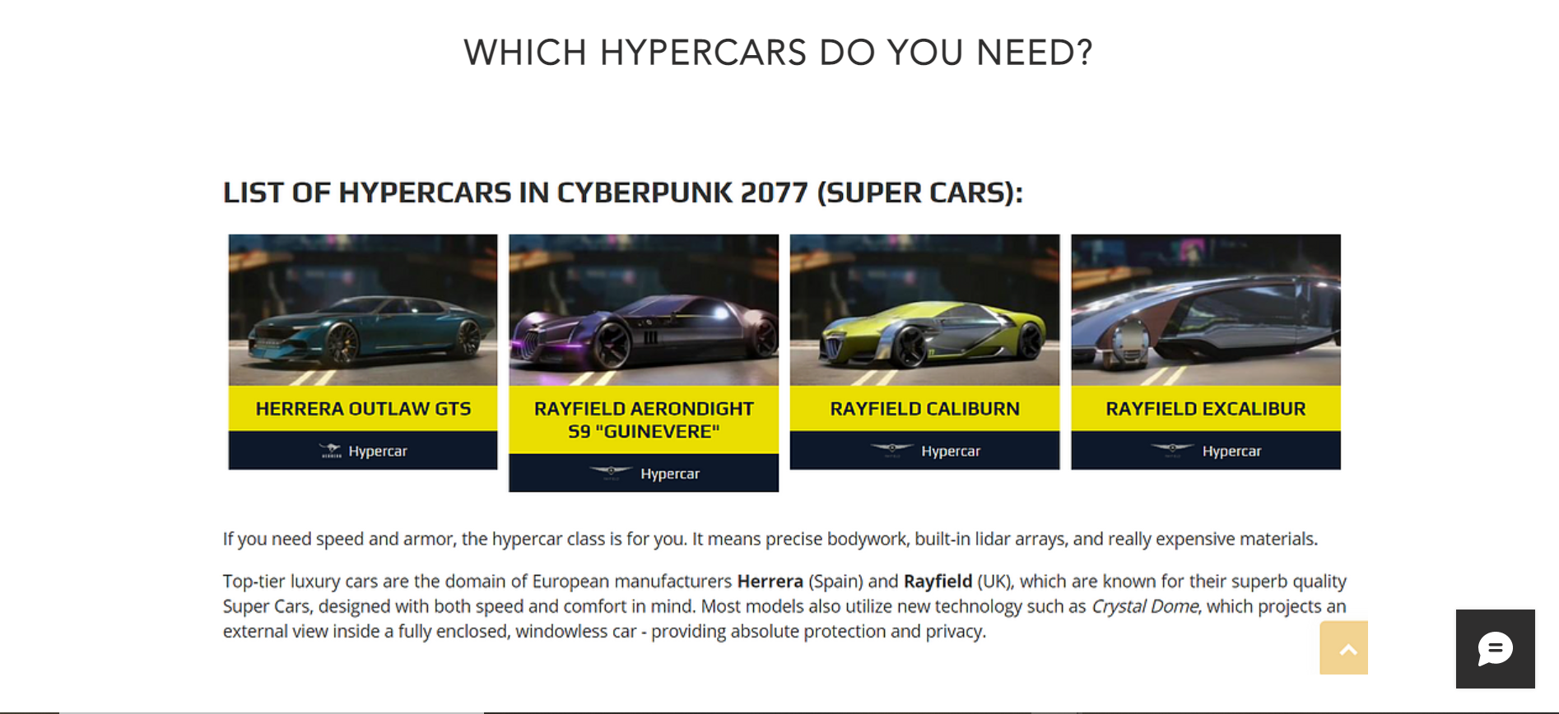 ***Figure 7: g.) CARS Page (2)***

***Figure 8: h.) INSURANCE Page***

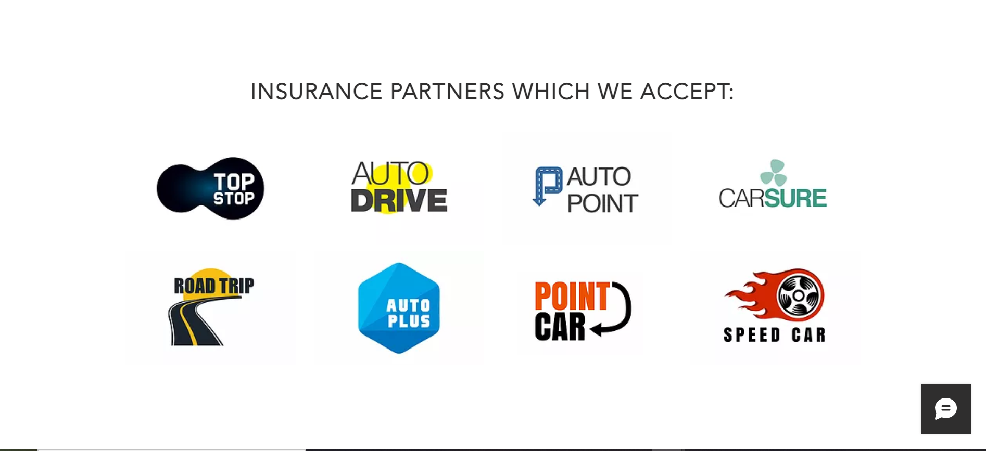***Figure 8: h.) INSURANCE PARTNERS***

# ***Task 2***

***Figure 9: i.) Sign Up Page***

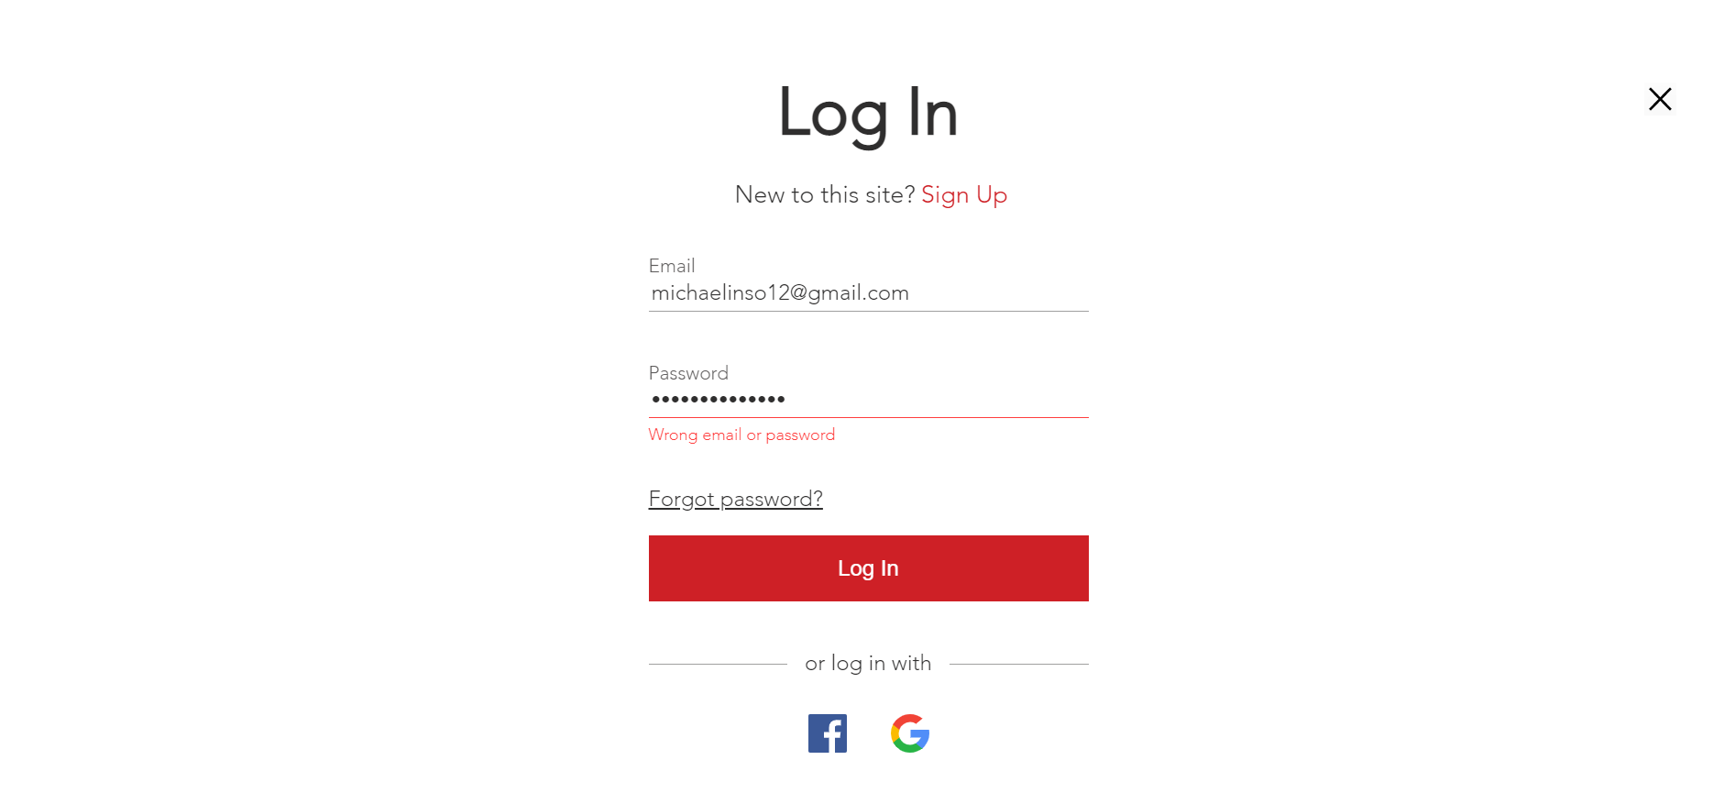

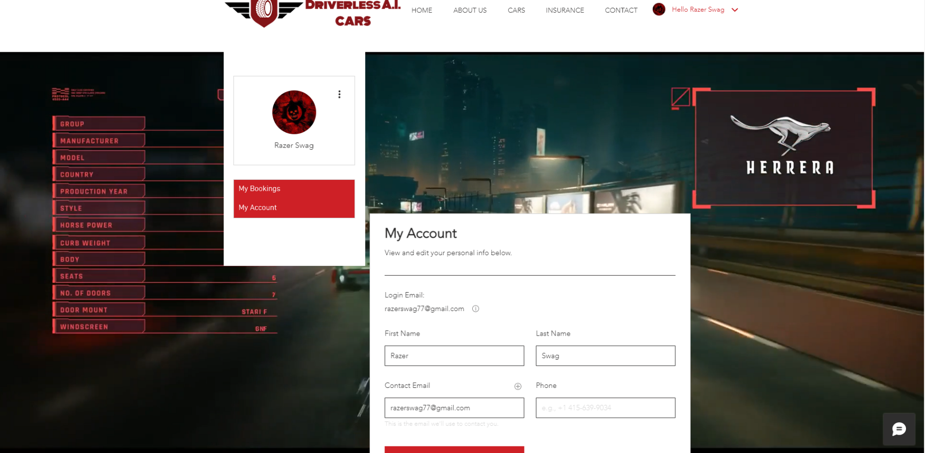***Figure 10: j.) Login Page (Wrong email or password)***

***Figure 11: k.) My Account Page***

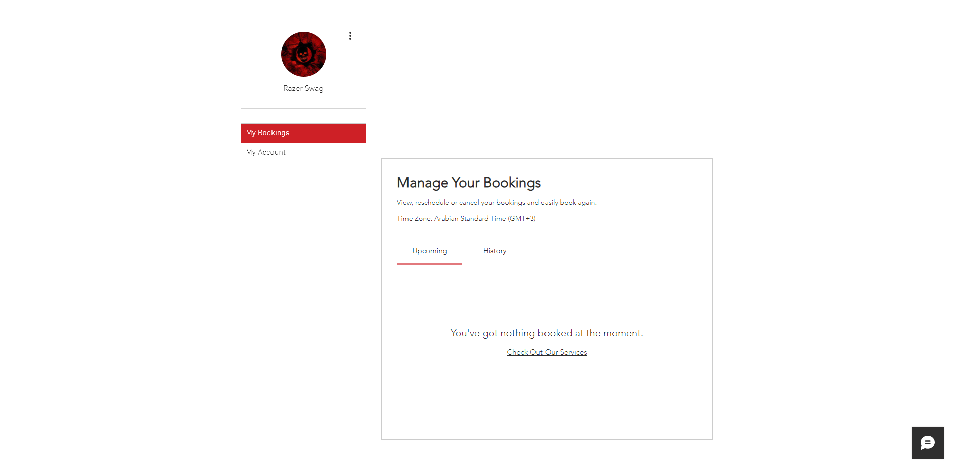***Figure 12: l.) My Bookings Page***

# ***Task 3***

***Figure 13: m.) CONTACT Page***

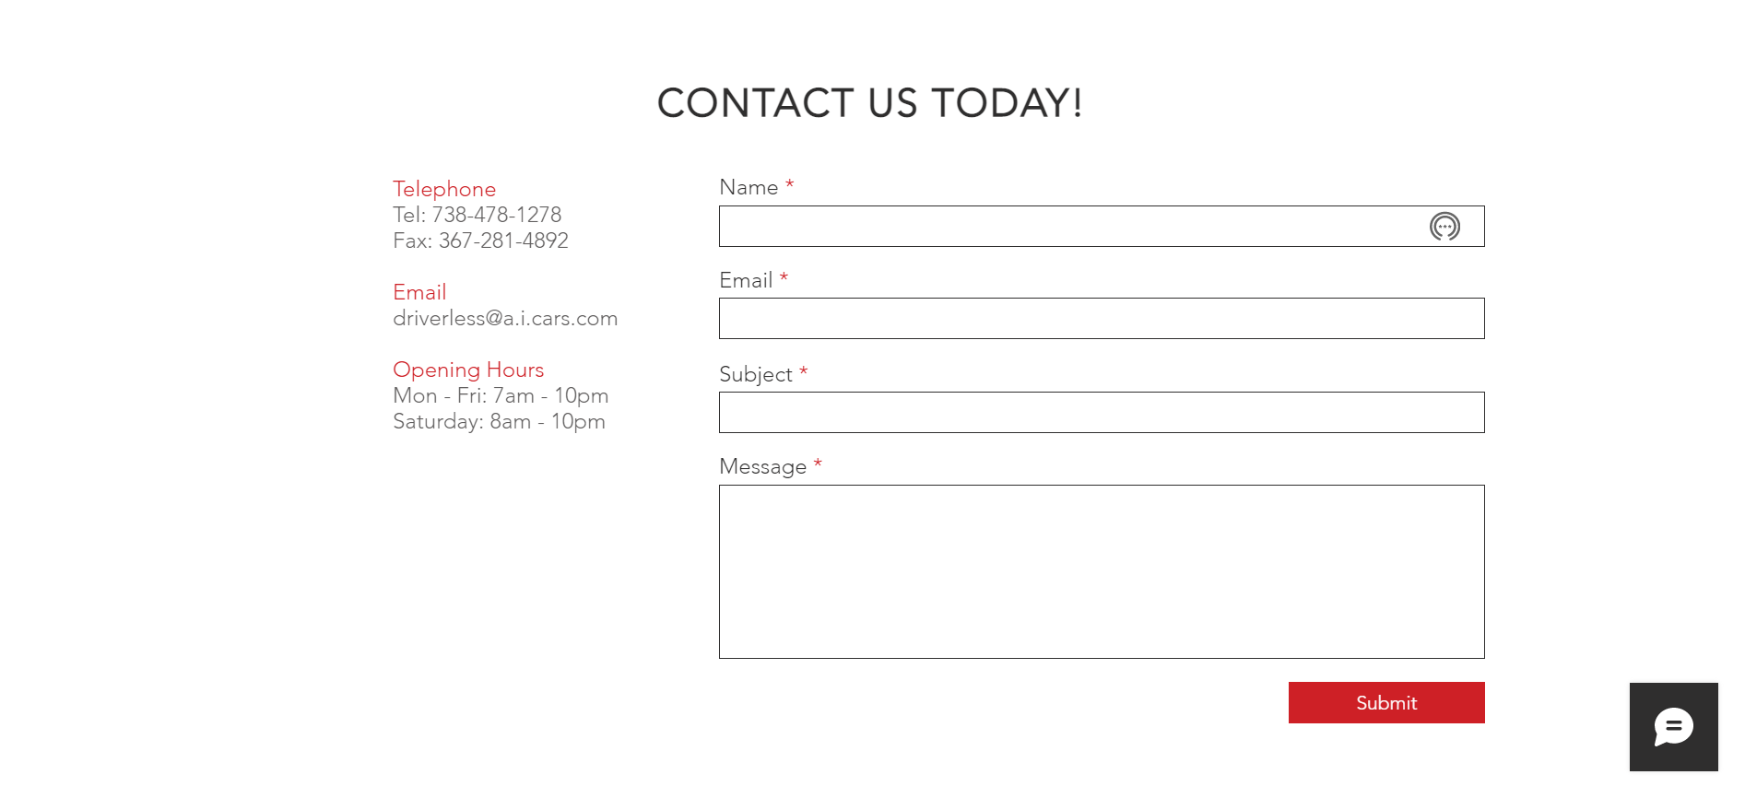***Figure 14: n.) Contact Us Page***

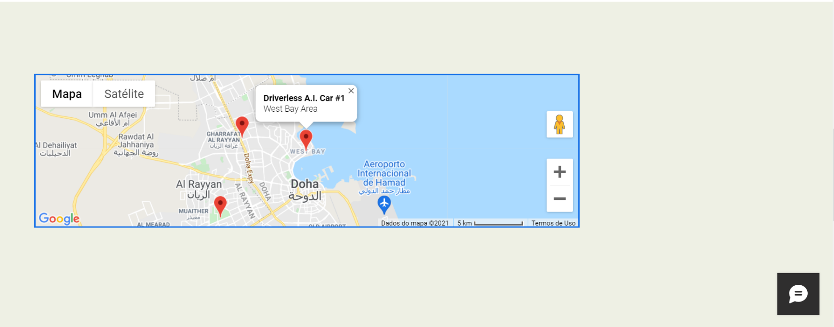

***Figure 15: o.) Map Page***

***Figure 15: p.) FAQ Page***

# ***Task 4***

The website is complete with all HOME, ABOUT US, CARS, INSURANCE, CONTACT, AND USER LOGIN & SIGN UP ACCOUNT. Highly simplistic design with each movable picture on each page and (background videos). Very fluid when interacting with each page making it user astonished and stupefy in each scroll and click to the Driveless A.I. Cars website.

Visual Studio and Chrome DevTools are the web development tools I used to create and generate the website I made for Driverless A.I. car. Both of these tools are easily and readily available for everyone. It’s free, fast, and efficient. Anyone can use it without prior knowledge of the tool because of its built-in instructions, simplicity, and accessibility.

XML and WDSL are great tools for web services and the website Driveless A.I. car contains a lot of its code on the website, straightforward and manageable to learn and code many people integrate these web services to their applications, software, and website, etc. An alternative for this web services are SOAP and REST they both focus in enhancing usability and efficiency.

Godaddy.com, Brinkster.com, and Somee.com are great web-hosting, Domain, Free.Net Hosting, MS SQL Hosting, Windows hosting, Cloud Servers, Shared Hosting, and Virtual Servers, etc. You can easily create your website here and host them online and offline. They are one of the best web-hosting sites available on the internet.

One has to use diverse programming languages front-end & back-end from HTML 5, CSS 3, Java (Spring), JavaScript, which are mostly use in our modern website, applications, and software, etc... While Swift, Ruby on Rails, Objective C, are mostly in Apple browsers and products, etc. Redis, and PHP, etc., and Framework from React, Vue, Angular, and Webpack, etc., and styling with Bootstrap and Material UI. Using database RDBMS from MySql, MSQL, or Postgres while you can also use NoSQL like Mongo, Casandra, CouchDB, and Elasticsearch, etc. I learn some of these programming languages in college I attend in past high school and current college Aptech Qatar. And I’m grateful to the teachers and professor for teaching and training me most of this programming languages and software.

Great DevOps for a project like this would be Azure by Microsoft you can also use NIGNIX, AWS by Amazon, and ELK, etc. We can also automate our project to make it doable with Ansible, Chef and Jenkins, etc. You can run it with visualization like VMware, Docker, Bladecenter, Kubernetes, Hyper-V, and Vagrant, etc. Planning to develop it with mobile you might want to learn Java, Kotlin, SDK, Swift, and Objective C, etc. You can also cross-platform using React Native, Ionic, PWA, Xamarin and Unity, etc. Most of this software are free and can readily be used and installed by the user.

Dynamic or Static website development is an exhilarating part of being a software engineer & developer being able to make a website according to your blueprint or diagram. Ideas and creativity are drafted before designing your website, having a blueprint and layout is very important for every web developer. Making it work with different background styles, effects, images, and fonts, etc. My website has a live background video effect but I can’t show it here since we can only submit png/jpeg/jpg with our project. It would be great if you can submit our video or gif of future projects.

A secured website is also the main objective of developing a dynamic or static website making it invulnerable to SQL injection, Cross-site scripting (XSS), DNS Hijacking, Denial-of-services (DOS), and Distributed-Denial-of Service (DDOS), etc. Many beginner website designers and developers are particularly susceptible to this kind of breach and exploits. I recommend learning fundamentals in website penetration testing if you want to make your website permanent and secure. Also having HTTPS that has HSTPS enabled will help your website be secured, encrypted, data integration, and authenticated.

I used a lot of futuristic-tech images for the project and I was highly inspired by Cyberpunk themes and the futuristic world. The website I made is simplistic in design but highly innovative in the idea and conceptual delivery of the product. Real-world application of this project or concept is possible with our modern technology, I would do this project and website again for a hobby, work, and for a company, etc.

Building the future requires a lot of innovation and going retro as the “old as the new” as we build our technology and modernize making technology norm in our daily lives, people having their lives change because of our technological innovation in the past 50 years, saving countless of lives, making our communication easier, giving us unlimited entertainment, and most of is connecting to other people around the globe.

Artificial Intelligence integration in the project was highly commendable. Amalgamating it into a vehicle like a car is the main subject of this assignment/project. Real-world examples of this project are companies like Tesla, Waymo, Nutonomy, AutoX, and Comma.ai, etc. They are huge big-tech companies of the United States and come of these companies have manufacturers and companies all over the world.

Cyberpunk 2077 vehicles have a great overall design. It has all kinds of cars, motorcycles, aerial vehicles planes and helicopters and as well boats and drones, etc. The cars in CyberPunk 2077 come in different classes: economy, heavy-duty, sports cars, executive, and hypercars. There are a lot of options for a diverse player from different brands, classes, and models. Artificial Intelligence is also integrated into cars for example Delmain Cabs are taxis that are operated and administered by artificial intelligence.

I’m a massive gamer and a great fan of CD Projekt Red S.A. since their distinguished accomplishment with Witcher 3: Wild Hunt and its past Witcher predecessor open-world adventure game. I finished both of the games and enjoyed it etc. I find an eminent inspiration to Cyberpunk 2077 which made this Dynamic Website into completion.

# ***Task 5***

It’s hard work and vigorous task to develop a website alone and I recommend it with a group or a team so you can easily broaden and widen your idea/proposition for the project or the website. Driverless A.I. Cars a great conceptual company that could make a reality someday in the succeeding future

I’m very proud of this project since I can accomplish these projects with a lot of extensive knowledge of programming and software development. I would make this project again in the field of Artificial Intelligence, Machine Learning, and Deep Learning, etc. Also, Virtual Reality and Augmented Reality would be great and fun to work with too.

Task 4 mostly summarizes the project. It has all the explanations and ideas I had for this project of Website Development for Driverless A.I. Cars, and I’m happy with the work I had done. I had no help with my project and ideas mostly come from the net and myself.

This project is stressful and difficult having a 1-month deadline also made it anxiety-driven for me. Pandemic and quarantine also took a toll on my me, family, and friends' mental and emotional health. Also not being able to go back home-town and travel is very frustrating, we all had the challenge of last year's covid-19 pandemic and it all took a toll on our mental and emotional health changing our perception about public health, socialization, and sanitation. I hope this year 2021-2022 would all go back to normal.

**References:**

**Bibliography**

[**https://cyberpunk.fandom.com/wiki/Cyberpunk_2077_Vehicles**](https://cyberpunk.fandom.com/wiki/Cyberpunk_2077_Vehicles)

**https://cyberpunk.fandom.com/wiki/Rayfield**

[**https://www.npmjs.com/package/sanitize-html**](https://www.npmjs.com/package/sanitize-html)

[**https://www.w3schools.com/sql/sql_injection.asp**](https://www.w3schools.com/sql/sql_injection.asp)

[**https://owasp.org/www-community/attacks/Command_Injection**](https://owasp.org/www-community/attacks/Command_Injection)

Pages: 18

Words: 2,125

Characters (no spaces): 10,906

Characters (with spaces): 12,981

Paragraphs: 121

Lines: 331